
NATIONAL AERONAUTICS AND SPACE ADMINISTRATION

FINAL

UPDATE FORMS APOLLO 7

AS-205/CSM-101

(OCTOBER 11 LAUNCH)

PREPARED BY

FLIGHT PLANNING BRANCH
FLIGHT CREW SUPPORT DIVISION

MANNED SPACECRAFT CENTER
HOUSTON, TEXAS

Flight Data

Spacecraft System Data
 | 1 | 2 | 3 | 4 | 5 | 6
GET (hhh:mm)
SPS Tank Temp (°F)
SPS He PRESS (psia)
SPS N2A PRESS (psia)
SPS N2B PRESS (psia)
SPS QTY (%)
SM A PKG TEMP (°F)
SM B PKG TEMP (°F)
SM C PKG TEMP (°F)
SM D PKG TEMP (°F)
SM A He PRESS (psia)
SM B He PRESS (psia)
SM C He PRESS (psia)
SM D He PRESS (psia)
SM A He TEMP (°F)
SM B He TEMP (°F)
SM C He TEMP (°F)
SM D He TEMP (°F)
SM A QTY (lbs)
SM B QTY (lbs)
SM C QTY (lbs)
SM D QTY (lbs)
EPS H2 QTY (%)
EPS O2 QTY (%)
FC1 AMPS
FC2 AMPS
FC3 AMPS
MNA VOLTS
MNB VOLTS
BAT A VOLTS
BAT B VOLTS
Pri RAD IN TEMP (°F)
Pri RAD OUT TEMP (°F)
Pri EVP OUT TEMP (°F)
GLY PUMP PRESS
SUIT TEMP (°F)
CAB TEMP (°F)
SUIT PRESS (psia)
CAB PRESS (psia)
CO2 PART PRESS(mmHg)

Spacecraft System Data (page 2)
 | 7 | 8 | 9 | 10 | 11 | 12
GET (hhh:mm)
SPS Tank Temp (°F)
SPS He PRESS (psia)
SPS N2A PRESS (psia)
SPS N2B PRESS (psia)
SPS QTY (%)
SM A PKG TEMP (°F)
SM B PKG TEMP (°F)
SM C PKG TEMP (°F)
SM D PKG TEMP (°F)
SM A He PRESS (psia)
SM B He PRESS (psia)
SM C He PRESS (psia)
SM D He PRESS (psia)
SM A He TEMP (°F)
SM B He TEMP (°F)
SM C He TEMP (°F)
SM D He TEMP (°F)
SM A QTY (lbs)
SM B QTY (lbs)
SM C QTY (lbs)
SM D QTY (lbs)
EPS H2 QTY (%)
EPS O2 QTY (%)
FC1 AMPS
FC2 AMPS
FC3 AMPS
MNA VOLTS
MNB VOLTS
BAT A VOLTS
BAT B VOLTS
Pri RAD IN TEMP (°F)
Pri RAD OUT TEMP (°F)
Pri EVP OUT TEMP (°F)
GLY PUMP PRESS
SUIT TEMP (°F)
CAB TEMP (°F)
SUIT PRESS (psia)
CAB PRESS (psia)
CO2 PART PRESS(mmHg)

LVPD (Launch Vehicle Pressure Display)
Event | GET | OXID Press  (psi) |  | FUEL Press  (psi)
During S-IVB
Burn (~6:00)
After Insertion
Before S-IVB
Passivation
After S-IVB
Passivation

Insertion Data
N62 VI (fps) |  | N44 HA(nm)
H DOT(nm) |  | HP(nm)
H PAD(nm) |  | TFF (m-s)

ATT Ref Comparison Check S-IVB Passivation dV
 | R | P | 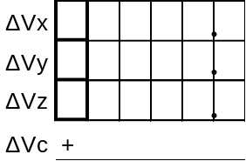  Y

DSKY

GDC

Inverter & Battery Voltage Checks

Inverter AC1/MNA ΦA_____, ΦB_____, ΦC_____

#3 Voltages AC2/MNB ΦA_____, ΦB_____, ΦC_____

Battery Voltages A:_____, B:_____ , C:_____

Pyro Batteries A:_____, B:_____

EMS ∆V Test & Bias Check

EMS Null Bias: _________

PIPA Bias Measurement

PIPA Counts: X_____ Y_____ Z_____

Retro Attitude Test
 | Day |  | Night
 | Plan | Actual | Plan | Actual
GET | 006:10 |  | 006:50
R | 179° |  | 180°
P | 138° |  | 339°
Y | 000° |  | 359°

COAS LOS Determination

SA______,TA______

Sextant Calibration
GET | Star | TRUN BIAS  N87(.001°)

Attitude Control Tests

Maneuver Data
Mnvr Purpose
TIG (hhh)
(mm)
(ss)
N81 ΔVx (fps)*
ΔVy (fps)*
ΔVz (fps)*
N42 ΔVt (fps)*
EMS ΔVc (fps)
N44 HA(nm)**
HP(nm)**
SPS QTY (%)
After Burn:
N85 ΔVx (fps)
ΔVy (fps)
ΔVz (fps)
EMS ΔVc (fps)
N44 HA(nm)**
HP(nm)**
SPS QTY (%)
Mnvr Purpose
TIG (hhh)
(mm)
(ss)
N81 ΔVx (fps)*
ΔVy (fps)*
ΔVz (fps)*
N42 ΔVt (fps)*
EMS ΔVc (fps)
N44 HA(nm)**
HP(nm)**
SPS QTY (%)
After Burn:
N85 ΔVx (fps)
ΔVy (fps)
ΔVz (fps)
EMS ΔVc (fps)
N44 HA(nm)**
HP(nm)**
SPS QTY (%)
* N81, & N42 data obtained from P30
** V82E to display orbital parameters

IMU Alignment Data
Record data from each P52/P54 Alignment.
GET  Start | P52/54  Option  (N06) | 1ST  Star | 2nd  Star | Angle Diff  (N05) | Gyro Torque Angles  N93 (.001°)
 |  |  |  |  | OG | IG | MG

P22 Orbital Navigation Data
P22 Landmarks: (Planned landmarks listed. Space is provided for unknown landmarks)
GET | Landmark | N89 (.001°/.01nm)
GET | Landmark | LAT | LONG/2 | ALT
122:03 | Punta Yoyameko (10) | +29.039 | -56.292 | +000.10
122:13 | Point Chimanche (67) | +17.924 | -35.827 | -001.52
122:24 | Augusto Severo Aiport (141) | -05.950 | -17.622 | -002.48
142:37 | Santa Eugenia (8) | +28.011 | -57.541 | -000.08
142:44 | Tyndall AFB (37) | +30.244 | -42.791 | +000.30
142:59 | Fogo (209) | +15.043 | -12.176 | -001.84
144:13 | Biggs AFB (18) | +32.028 | -53.188 | +000.62
144:46 | Walvis Bay (225) | -23.020 | +07.223 | -000.85
145:46 | Punta Yoyameko (10) | +17.924 | -35.827 | -001.52
146:07 | Cabedelo (142) | -07.012 | -17.422 | -002.44
214:35 | Cape Florida (48) | +25.817 | -40.079 | -000.43
215:01 | Walvis Bay (225) | -23.020 | +07.223 | -000.85
216:03 | Guaymas (11) | +27.998 | -55.443 | -000.08
216:14 | Maracaibo (128) | +10.646 | -35.769 | -002.22
216:24 | Ponta Manguinho (144) | -10.575 | -18.209 | -002.22
216:37 | Alexander Bay (227) | -28.799 | +08.230 | +000.06

P22 Results: Record data from each P22
GET | Landmark | N49(.01nm/.1fps) |  | SV  Updtd?
GET | Landmark | ∆R | ∆V | SV  Updtd?
 |  |  |  | Y / N

P23 Cislunar Navigation Data
Record data from each P23:
N49: State Vector Update
GET | Star | Horiz.  Option | N49(.01nm/.1fps) |  | SV  Updtd?
GET | Star | Horiz.  Option | ∆R | ∆V | SV  Updtd?
 |  |  |  |  | Y / N

Cryo Stratification Test
1. H2(O2) HEATERS (both) - OFF
H2(O2) FANS (both) – OFF
Record Step 1. data (GET, Press, Qty)
2. When either H2(O2) Tank Pressure reaches 230(850)psia
H2(O2) HEATERS (both) – ON
Record Step 2. data
3. When either H2(O2) Tank Pressure reaches 260-265(915)psia
Record Step 3. data
H2(O2) HEATERS (both) - OFF
H2(O2) FANS (both) – ON
4. Record Data at one minute intervals for 4 min.
5. H2(O2) HEATERS (both) - AUTO
H2(O2) FANS (both) – AUTO

Hydrogen Stratification Test
QTY | Step/GET | Press (psia) |  | Qty(%)
QTY | Step/GET | 1 | 2 | 1 | 2
85%  to  90% | 1.
85%  to  90% | 2.
85%  to  90% | 3.
85%  to  90% | 4. +1 min
85%  to  90% | +2 min
85%  to  90% | +3 min
85%  to  90% | +4 min
55%  to  60% | 1.
55%  to  60% | 2.
55%  to  60% | 3.
55%  to  60% | 4. +1 min
55%  to  60% | +2 min
55%  to  60% | +3 min
55%  to  60% | +4 min
10%  to  20% | 1.
10%  to  20% | 2.
10%  to  20% | 3.
10%  to  20% | 4. +1 min
10%  to  20% | +2 min
10%  to  20% | +3 min
10%  to  20% | +4 min

Oxygen Stratification Test
QTY | Step/GET | Press (psia) |  | Qty(%)
QTY | Step/GET | 1 | 2 | 1 | 2
85%  to  90% | 1.
85%  to  90% | 2.
85%  to  90% | 3.
85%  to  90% | 4. +1 min
85%  to  90% | +2 min
85%  to  90% | +3 min
85%  to  90% | +4 min
55%  to  60% | 1.
55%  to  60% | 2.
55%  to  60% | 3.
55%  to  60% | 4. +1 min
55%  to  60% | +2 min
55%  to  60% | +3 min
55%  to  60% | +4 min
10%  to  20% | 1.
10%  to  20% | 2.
10%  to  20% | 3.
10%  to  20% | 4. +1 min
10%  to  20% | +2 min
10%  to  20% | +3 min
10%  to  20% | +4 min

CONSUMABLES ANALYSIS

SM RCS Budget

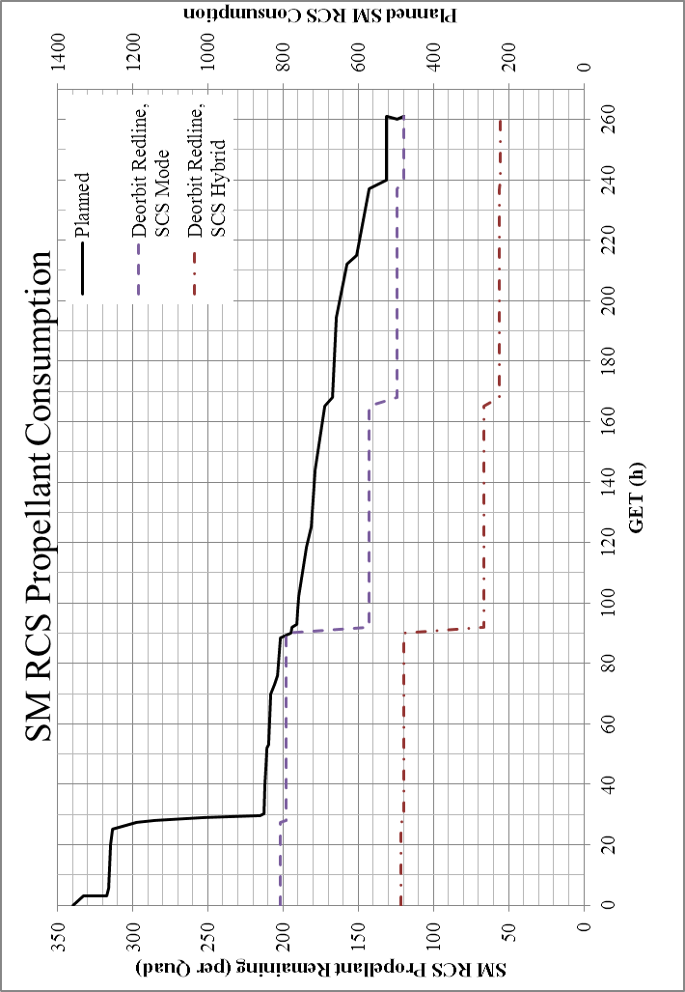

Cryogenic Budget

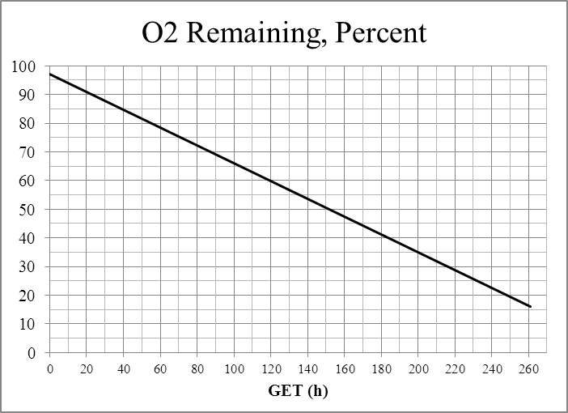

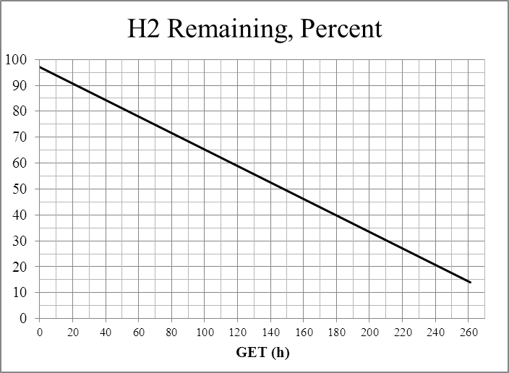

Update Forms
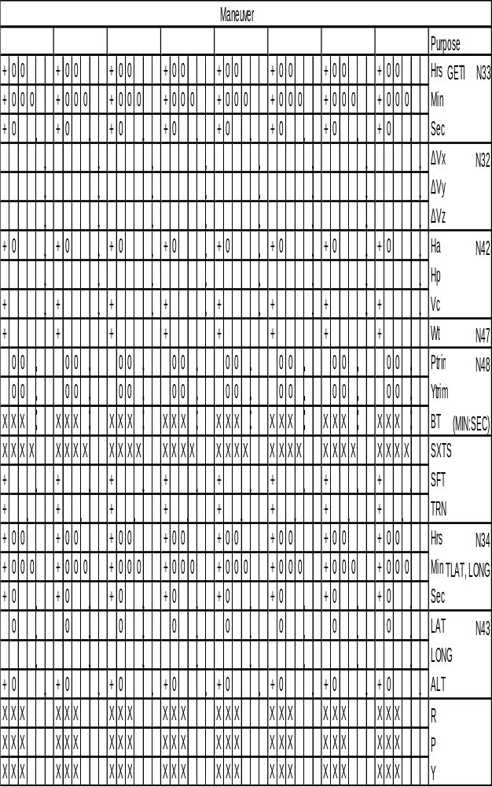

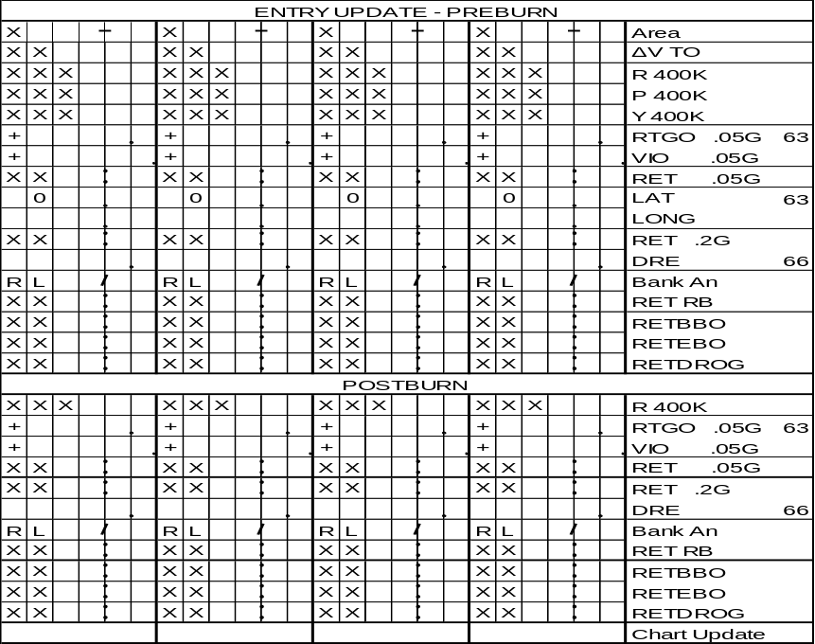

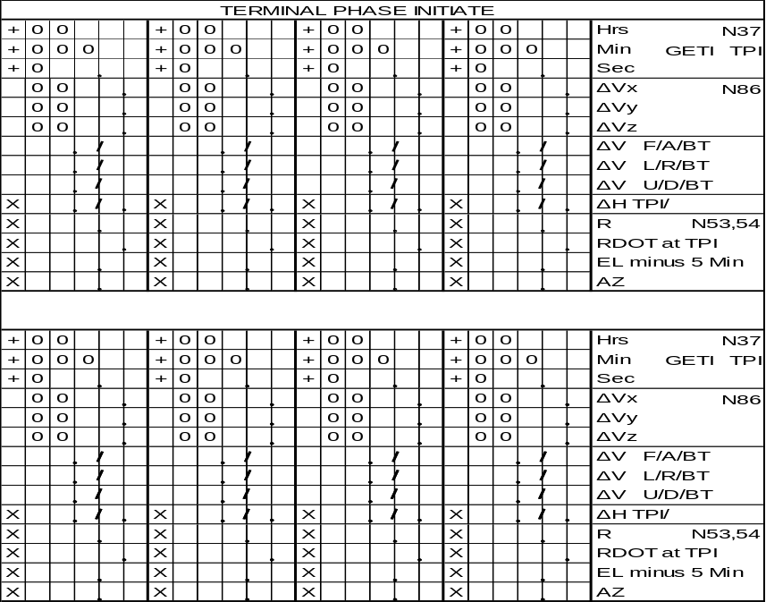

THIS PAGE INTENTIONALLY LEFT BLANK

